ACUPUNCTURE: STEM-CELL INFLUENCE
Laurance Johnston, Ph.D.
Elsewhere, I’ve discussed acupuncture and its potential to restore some function after spinal cord injury – perhaps, in part, through its ability to influence regeneration-enhancing stem cells. This update summarizes studies documenting these possibilities.
Traditional Theory
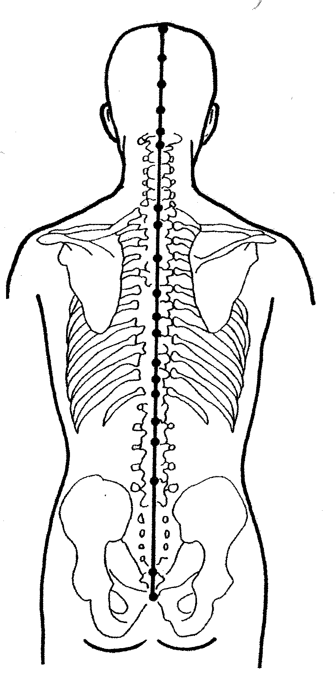
In brief review, under Traditional Chinese Medicine (TCM), acupuncture stimulates specific skin points by either inserting needles; applying heat, pressure, or massage; or using various energy-emitting devices. It originally evolved from observations that a disorder was associated with an increased sensitivity in specific skin areas. These areas were consistently linked to a specific organ and followed a defined topographical pattern. Called meridians, these patterns served as pathways for life-force qi energy. Qi flow through these meridians could be regulated by the stimulation of acupuncture points located periodically along the meridians.
Under TCM theory, traumatic SCI damages the Du or Governor meridian, which, in turn, affects qi circulation for the entire body. The goal of treatment is to clear and activate meridian channels, reversing qi stagnation.
Studies
The World Health Organization has listed many disorders amenable to acupuncture, including those supported by more rigorously designed clinical trials. Accumulating evidence suggests that acupuncture also has the potential to restore some function after acute and perhaps chronic SCI.
Drs. Peter Dorsher and Peter McIntosh, Mayo Clinic (Jacksonville, Florida) have proposed a number of scientific mechanisms by which acupuncture could exert beneficial effects after SCI, including 1) decreasing the levels of proteins and cells fostering injury-site scar formation, 2) reducing the creation of damage-perpetuating, free-radical molecules, 3) lessening post-injury spinal-cord atrophy, 4) decreasing stress-related hormones, 5) increasing various regeneration-enhancing molecules, 6) stimulating blood flow to the injury area, and 7) releasing neuroprotective, endorphin-like molecules. As discussed below, acupuncture also may stimulate function-restoring stem cells.
In these discussions, it is important to note that only a relatively small percentage of working neurons need to cross the injury site to have significant function. Through the previously discussed mechanisms, acupuncture may help preserve enough neurons in acute injury or turn-on surviving, dormant neurons in chronic injury to tilt the balance toward function rather than paralysis.
Several SCI-focused acupuncture studies are summarized below. In some cases critics have questioned their rigor and, in turn, the amount of positive results. For example, some of the results may merely reflect spontaneous improvement in individuals with incomplete injuries.
· Dr. X. Gao et al (China) treated 261 individuals with SCI, of which 79% had been injured at least one year. Ninety-five percent had some improvement, such as enhanced sensation, bowel-and-bladder function, spasticity, and walking. The investigators believed that acupuncture improved spinal-cord circulation.
· Dr. H. J. Wang (China) treated 82 patients with SCI with electroacupuncture (application of a pulsating electrical current to acupuncture needles). Of these, 93% accrued functional benefits, including improved lower-limb and bowel-and-bladder function.
· Dr. P. T. Cheng and colleagues (Taiwan) showed that electroacupuncture-treated patients achieved balanced voiding in fewer days than controls. Patients starting acupuncture within three weeks of injury required fewer treatments compared to those treated later.
· Dr. A. M. Wong and associates (China) treated acutely injured patients with electrical and auricular (i.e., ear) acupuncture starting in the emergency room and measured improvement one-year post injury. Compared to controls, treated patients recovered more function.
· In eight patients, Dr. H. Honjo et al. (Japan) demonstrated that acupuncture increases bladder capacity, decreasing urinary incontinence.
· Dorsher and McIntosh reported that an individual with SCI becoming “completely continent of urine and able to void volitionally after treatment with electroacupuncture.”
· Dr. S. Nayak and colleagues (USA) reported that 50% of acupuncture-treated patients with SCI had chronic pain relief.
· Dr. T. A. Dyson-Hudson et al. (USA) suggested that acupuncture reduced chronic shoulder pain in wheelchair users with SCI.
· Dr. L. M. Rapson et al. (Canada) treated 36 subjects with below-level central neuropathic pain characterized by generalized burning with electroacupuncture. Twenty-four had reduced pain.
Acupuncture & Stem Cells
Stem cells are going to play an ever-increasing role in restoring function lost by disability, disease, or the entropy of aging. From conception until death, they are the cells of renewal and regeneration through which many regenerative energies are mediated. And when our body’s own stem cells are insufficient to do the job, transplanted stem cells may provide the needed regenerative boost.
Harvard University’s Dr. Charles Shang believes that the acupuncture system and stem cells are closely linked through an “organizing center network” composed of under-differentiated, electromagnetically sensitive cells. This network is created early in embryogenesis before the formation of other body systems (e.g., spinal cord) and has the potential to influence these later-formed systems throughout life. Under this model, acupuncture has extensive growth-control effects and can trigger network stem cells into action.
As a crude analogy, view the acupuncture-sensitive “organizing center network” as a behind-the-lines’ general ready to send in green reserve troops (i.e., stem cells) who will evolve into the front-line combatants replacing those who have fallen from the attacks of disease, trauma, and aging. In the case of transplanted stem cells, Shang speculates that they can be recruited into a new network for repair and regeneration.
Indeed, scientists have shown that acupuncture influences stem-cell expression in animal models of neurological disorders, including SCI:
· In rats with transected spinal cords, Dr Y. Ding and colleagues (China) concluded that electroacupuncture promotes the survival and differentiation of transplanted stem cells. Transplantation combined with electroacupuncture “could promote axonal regeneration and partial locomotor recovery in the transected spinal cord in rats and indicates a promising avenue of treatment of spinal cord injury.”
· In another article, these investigators concluded that 1) electroacupuncture promotes the differentiation of stem cells and regeneration of nerve fibers in the injured cord through the induction of neural growth factors, and 2) the combination of electroacupuncture and stem-cell transplantation improves functioning of paralyzed hind limbs.
· Dr. Z. Sun et al (China) demonstrated that treatment with electroacupuncture combined with bone-marrow-derived stem-cell transplantation restored more function in rats than either treatment by itself. The investigators attributed this improved outcome to the enhanced differentiation of the transplanted stem-cells into neuronal stem cells.
· Dr. C. Yang and colleagues (China) concluded that electroacupuncture inhibits in rats the proliferation of astrocytes (neuronal support cells) after SCI and prevents the formation of the glial scar.
Conclusion
Acupuncture is a nothing-to-lose-and-perhaps-everything-to-gain therapy that should be used not only after SCI but also in conjunction with stem-cell transplantation. It is stunning to think that acupuncture, one of mankind’s oldest therapies, may augment the effectiveness of stem-cell transplantation, one of mankind’s most contemporary treatments. Clearly, ancient wisdom often has much contemporary validity, even if it’s hard to explain through mechanisms that most biomedical scientists have been taught to understand.

